1. Casing Section

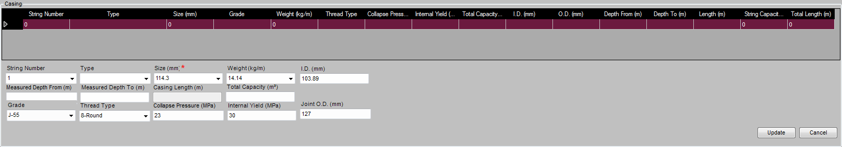

Behavior:

1. When initializing a record, Size List will be given full list of Casing Pipe sizes, Weight list are blank. Grade list is populated with all valid Casing Grade Types; Thread Type lists are populated will all Casing Thread Types. Thread Type field will be default to “8-Round”.
2. Choosing a Size, the Weight list will be filtered to only valid Weight options.
3. Choosing a Weight,  Inner Diameter will be looked up from Data Handbook.  The Capacity calculation will be triggered, if Measured Depth From and Measure Depth To has valid values, Total Capacity will be calculated.
4. Choosing a Grade, Collapse Pressure , Internal Yield  and Joint O.D. will be looked up from Data Handbook based on combination of Grade, Size and Weight .
5. Changing Thread Type, no look up and calculation will be triggered.
6. If Changing Measured Depth From and Measure Depth To values, Total Capacity will be calculated.
7. Drill Pipe Section

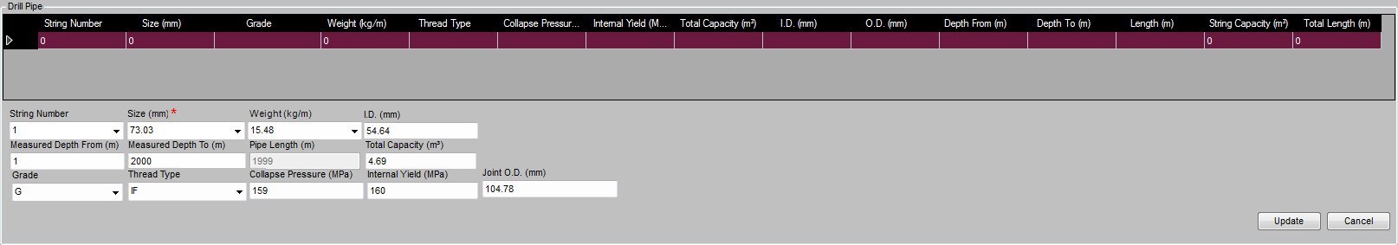

Behavior:

1. When initializing a record, Size List will be given full list of Drill Pipe sizes, Weight list are blank. Grade list is populated with all valid Drill Pipe Grade Types; Thread Type lists are populated will all Drill Pipe Thread Types. Thread Type field will be default to Blank.
2. Choosing a Size, the Weight list will be filtered to only valid Weight options.
3. Choosing a Weight,  Inner Diameter will be looked up from Data Handbook.  The Capacity calculation will be triggered, if Measured Depth From and Measure Depth To has valid values, Total Capacity will be calculated.
4. Choosing a Grade, Collapse Pressure , Internal Yield  and Joint O.D. will be looked up from Data Handbook based on combination of Grade, Size and Weight .
5. Changing Thread Type, no look up and calculation will be triggered.
6. If Changing Measured Depth From and Measure Depth To values, Total Capacity will be calculated.
7. Tubing Section

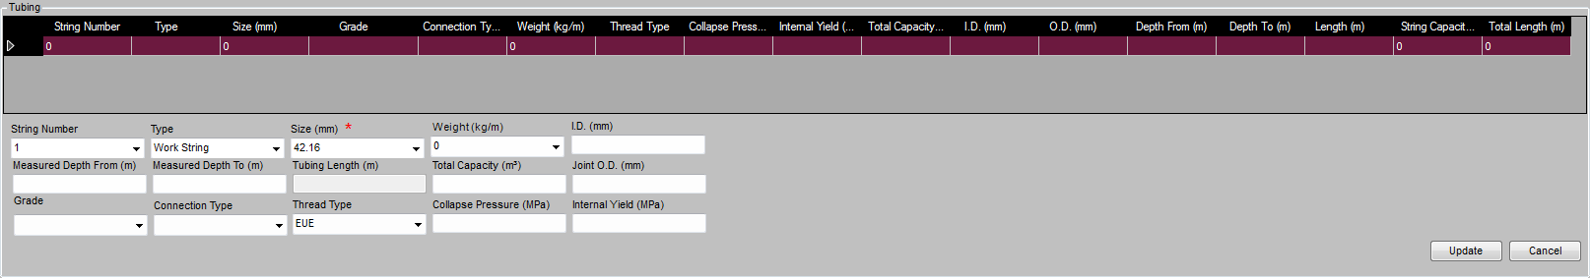

Behavior:

1. When initializing a record, Size List will be given full list of Tubing sizes, Weight list are blank. Grade list is populated with all valid Tubing Grade Types; Connection Type lists are populated will all Tubing Connection Types. Connection Type field will be default to Blank. Thread Type lists are populated will all Tubing Thread Types. Thread Type field will be default to Blank.
2. Choosing a Size, the Weight list will be filtered to only valid Weight options.
3. Choosing a Weight,  Inner Diameter will be looked up from Data Handbook.  The Capacity calculation will be triggered, if Measured Depth From and Measure Depth To has valid values, Total Capacity will be calculated.
4. Choosing a Grade, Collapse Pressure , Internal Yield  and Joint O.D. will be looked up from Data Handbook based on combination of Grade, Size and Weight .
5. Changing Thread Type, no look up and calculation will be triggered.
6. If Changing Measured Depth From and Measure Depth To values, Total Capacity will be calculated.

Question: In Tubing Handbook, Connection Type seems to be a factor for lookup weight in Data Handbook. However, client may only give Size and Weight, so we must look up Connection Type backwards. This is not logical, but it is the only way working. Is it ok?

1. Coiled Tubing Section

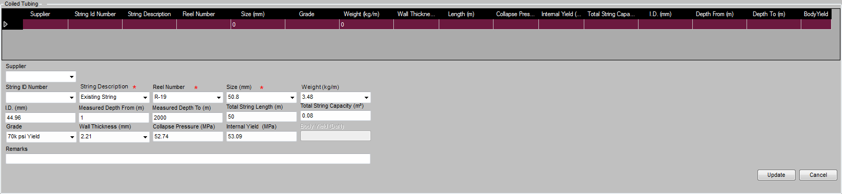

Behavior:

1. When initializing a record, Size List will be given full list of Coiled Tubing sizes, Weight list are blank. Grade list is populated with all valid Coiled Tubing Grade Types; Connection Type field will be default to Blank.
2. Choosing a Size, the Weight list will be filtered to only valid Weight options.
3. Choosing a Weight,  Inner Diameter will be looked up from Data Handbook.  The Capacity calculation will be triggered, if Measured Depth From and Measure Depth To has valid values, Total Capacity will be calculated.
4. Choosing a Grade, Collapse Pressure and Internal Yield will be looked up from Data Handbook based on combination of Grade, Size and Weight .
5. If Changing Measured Depth From and Measure Depth To values, Total Capacity will be calculated.

Question:

Currently in eService, Wall Thickness is a free-pick list populated with all options, should we make a read-only and populate it with the values determined by Size and Weight?